**Task on Bash-Scripting.**

1. Create on Bash script to check if a directory is available or not.

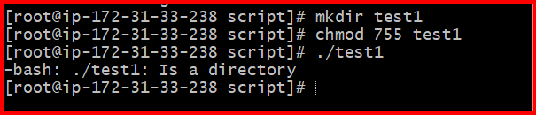

1. Create a bash script which will create multiple files.

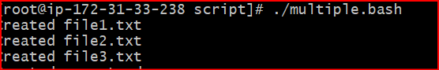

1. Create a bash script to take backup of a directory.

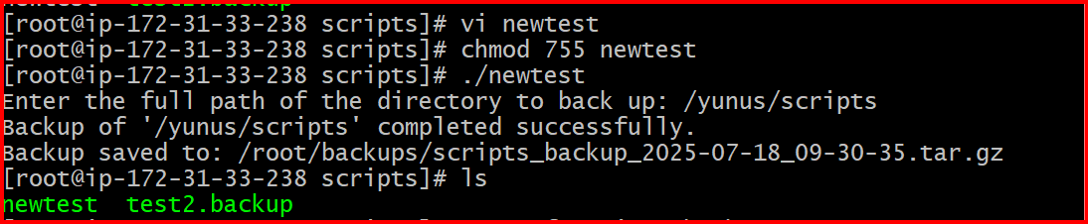

4. Create a bash script to install nginx in ec2 server.

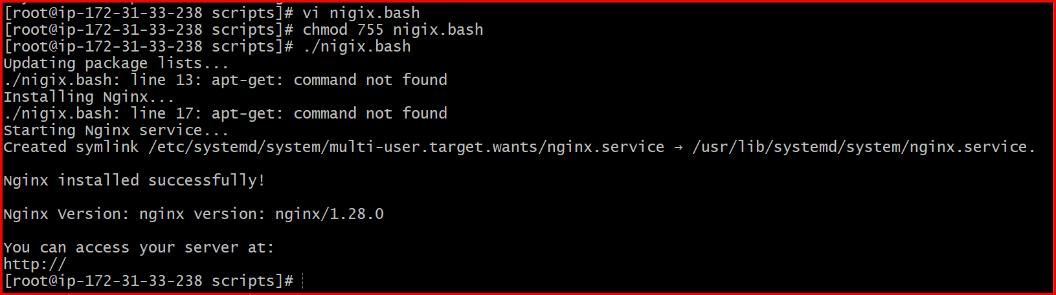

5.Create a bash script to install ApacheTomcat in ec2 server.

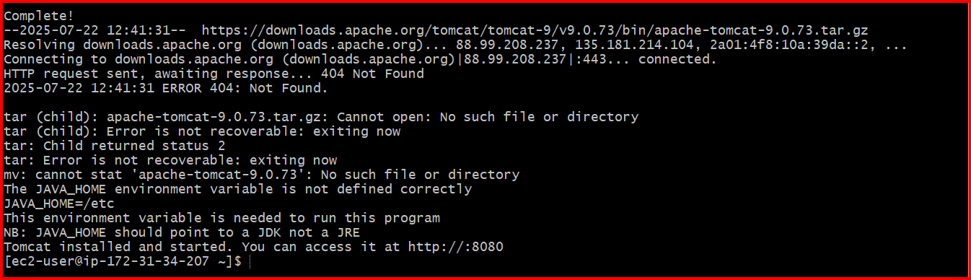

6. Create a bash script to check list if nginx service is running or not,if not running then script should start the service

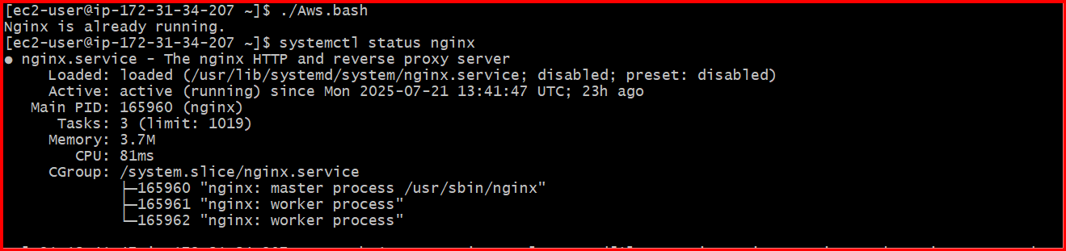

7. reate a bash script for calculator.

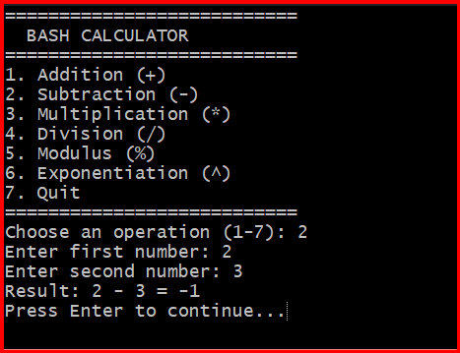

8. Create a bash script to check if directory is avaialble or not,if not then create a directory.

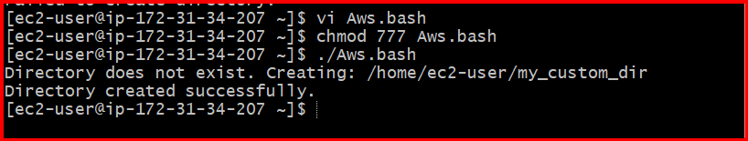

9. Create bash script to delete last 3 lines for a file.

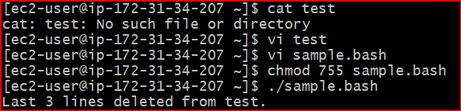

10. Bash script to monitor cpu and if it is more than 80% then send email notification.

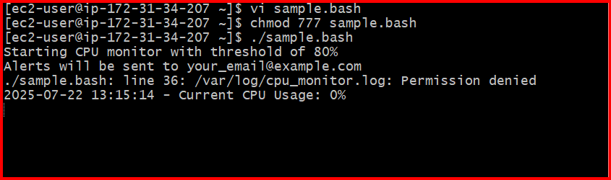

11. Bash script to monitor disk space and if it is more than 80% then send email notification.

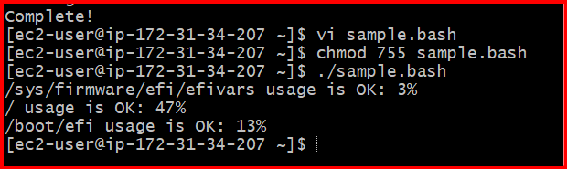

12. Bash script to monitor memory and if it is more than 80% then send email notification

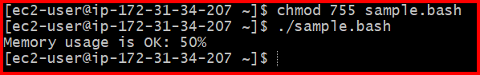

Crontabs

